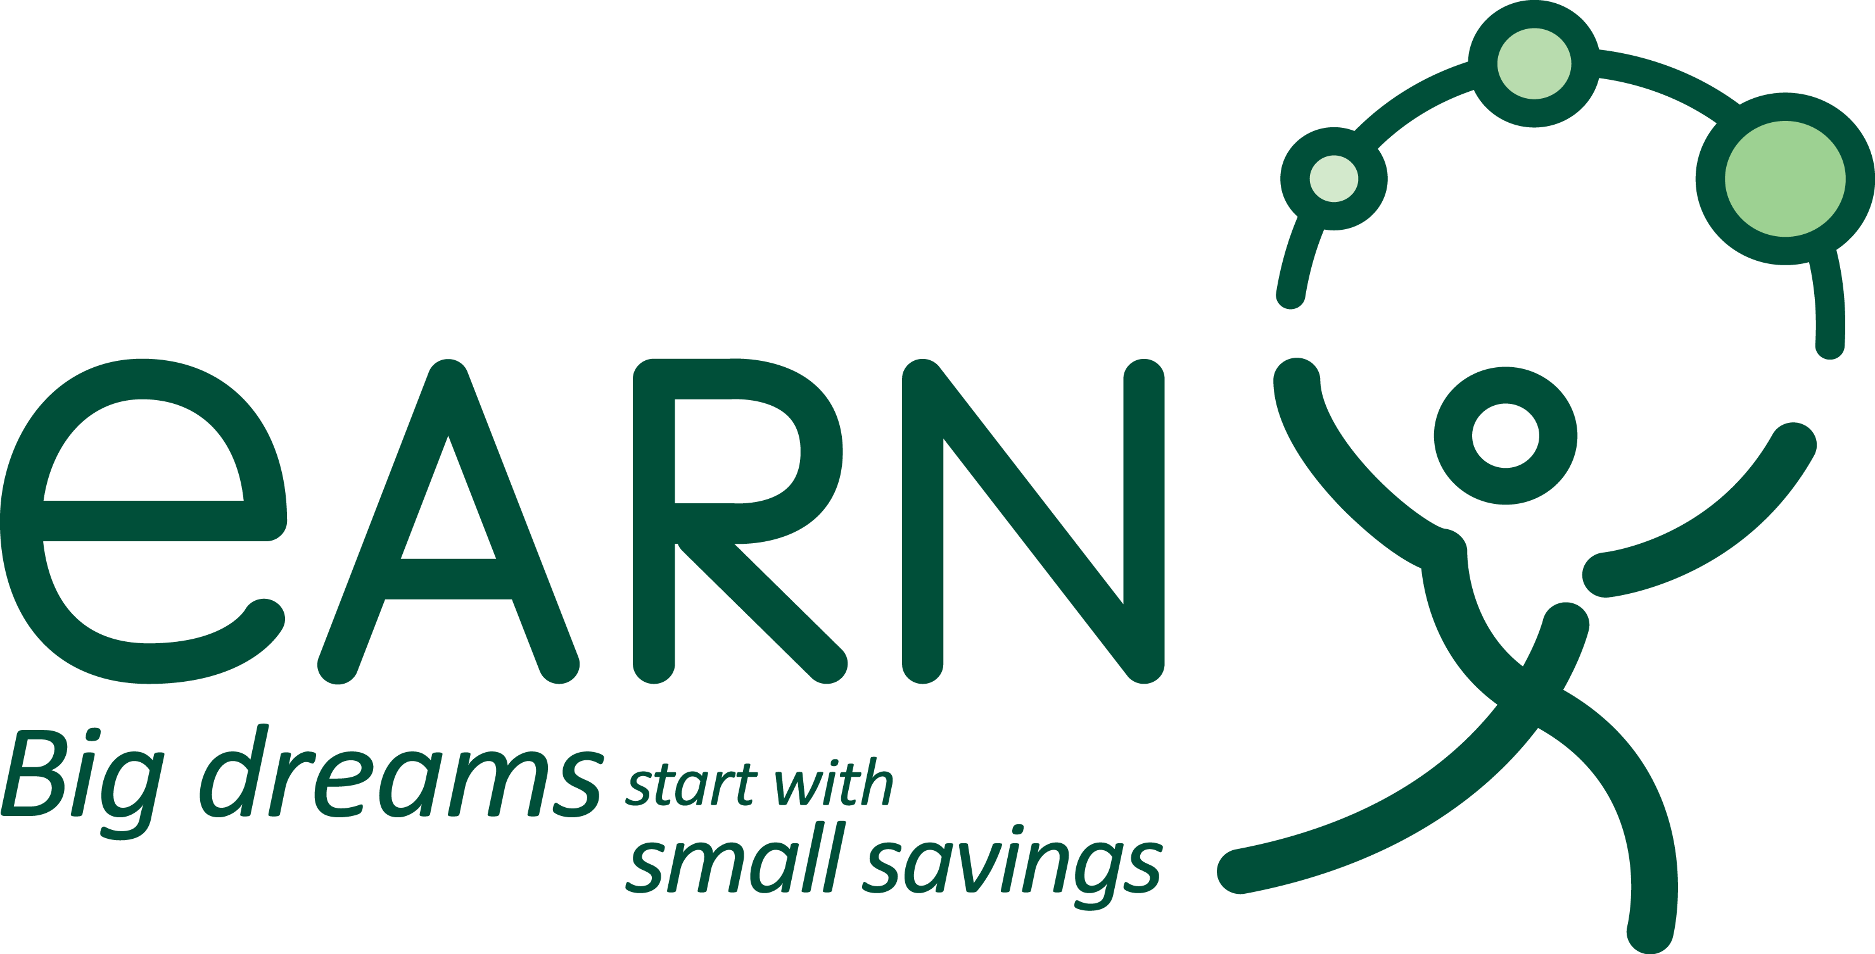  CONTACT  Ben Mangan  President and CEO  (415) 217-3662  ben@earn.org  EARN  235 Montgomery St., Suite 470  San Francisco, CA 94104  415.217.3660 | PRESS RELEASE  FOR IMMEDIATE RELEASE  EARN’s new Firefly Account Launches in  New York City with nonprofit partner Urban Upbound.  Firefly Account helps low-wage New Yorkers to start saving.  SAN FRANCISCO, FEBRUARY 24, 2014 –EARN, the leading nonprofit provider of goal-based savings products in the U.S., has announced a key partnership with Urban Upbound for EARN’s Firefly Account. The Firefly Account, designed to help the 132 million working Americans in or on the edge of poverty develop a lifelong habit of saving, signals EARN’s mission to help 1 million Americans save $1 billion by 2022.  “Brooklyn is my hometown, so I know how hard New Yorkers work to pursue their dreams – and how hard it is these days to get by,” said EARN CEO Ben Mangan. “EARN’s Firefly Account will help working New Yorkers build a habit of saving, and the financial capability that they need to get ahead. EARN is thrilled to have such a strong partner in Urban Upbound to begin this work in New York City.”  “The Firefly Account is a great way to introduce low-income workers to saving, and show people that they can actually do it,” said Ash Exantus, Credit Union CEO of Urban Upbound Federal Credit Union. “Launching Firefly through our tax preparation services helps introduce new members to the Credit Union, and gives them access to capital and the mindset shift of continuing the habit of saving.”  According to the Pew Charitable Trust, regular saving is among the leading indicators of poor Americans leaving the bottom 20% of the economy. With 21.2% of New Yorkers living below the federal poverty level, the Firefly Account is the first step these low-wage workers will take toward financial stability.  The Firefly Account uses interventions like financial incentives, notifications, reminders, and other support mechanisms to boost motivation and commitment to saving for goals. Individuals who save with the Firefly Account earn financial rewards each time they make at least $20 in deposits each month. Deposits can be made online anytime, and individuals can track their progress as they save.  The Firefly Account is made possible with the support of numerous key partners, as well as funding from Bank of America, Charles Schwab Bank, JP Morgan Chase, Levi Strauss, Capital One, Silicon Valley Community Foundation, Marcled Foundation, Walter & Elise Haas Fund and the Kresge Foundation.  About EARN  EARN is a national nonprofit that gives low-income working families the power to create prosperity for generations. As the nation’s leading microsavings provider, EARN gives families the tools to achieve life-changing goals such as saving for college, buying a first home, or starting a small business. EARN's ultimate vision is that millions of well-informed, low-wage American families will achieve financial success through proven strategies, fair public policy, and their own hard work.  Connect with EARN at http://www.earn.org, facebook.com/earn.org, and twitter.com/earn.  ###

